Document 2: Zombie snail parasites. The science of taxonomy.

Student Learning Outcome: To gain an understanding of the importance of integrating datasets to understand hierarchical taxonomy. Specifically, you will understand how to choose the right sources that confirm if a scientific name is considered a correct description of the taxon by the scientific community. In taxonomy, accepted names are considered valid.

Part 1: What is the valid scientific name? The importance of selecting relevant data sources

Before you begin, understanding what a biological database is and its uses is covered nicely, here: Biological database - Wikipedia

Question: Based on the information stated in the problems and challenges section of the page, why is it important to have integrative databases?

“Biological knowledge is distributed among countless databases. This sometimes makes it difficult to ensure the consistency of information, e.g. when different names are used for the same species or different data formats.”

Question: What is a curated data base? Why is it important to use a curated data source instead of a general website? A data base with content added or validated by experts in the field. A general website includes information that is not necessarily accurate as there is no oversight on content.

  - Practicing database use and validation with a zombie snail parasite. Back to OneZoom. In the search all life box, enter zombie snail parasite. The node should show the genus Leucochloridium. Zoom into the node and click on it to open the Wikipedia link. Notice, there are other options:
- Click on Genetics to enter website for National Center for Biological Inventory. You will enter the Taxonomy Browser home page. This serves as the interface between the name you have searched and the curated databases that include detailed information on the taxonomy, distribution, and interactions with other organisms. (***IF you need to refer back to this page for later use without starting again at OneZoom, use this link: Taxonomy browser (root) (nih.gov))

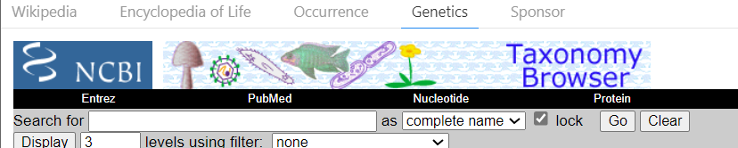

You will see the Lineage (full) appear below the grey box. Notice, the current system of naming species is quite different than classic Linnaean taxonomy as cladograms allow for many more branches and clades.

Question: In the list of Leucochloridium, how many species are unclassified? 8

Question: What is the meaning of unclassified? Taxonomically uncertain

Question: What does this disclaimer state at the bottom of the page? What does it recommend? The NCBI taxonomy database is not an authoritative source for nomenclature or classification - please consult the relevant scientific literature for the most reliable information.

Part 2 – What is the valid scientific name? The importance of taxonomists.

Define Taxonomist.

- Now it is time to validate the names listed in the list. The grey bar shows the term “linkout” . Click this box and hit GO.

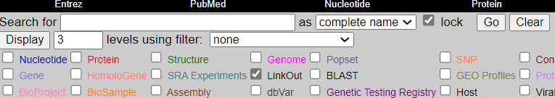

- You will see that the genus Leucochlorodium now has a word “linkout” in blue next to the name.
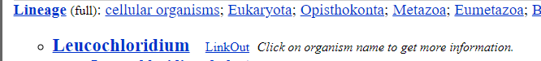

- Click LinkOut and a new tab appears with taxonomic information.

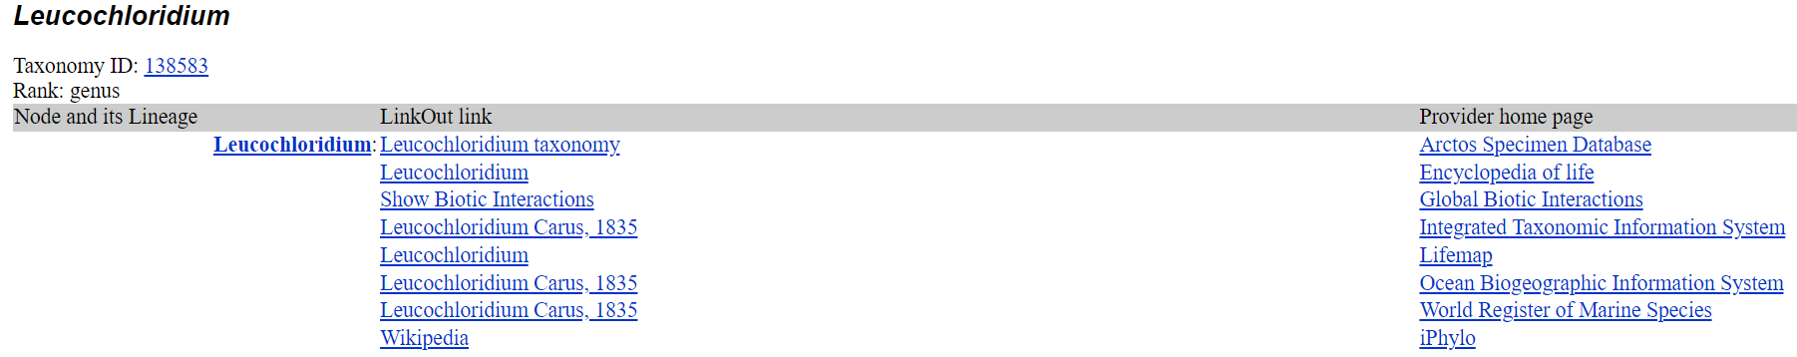

- Click the link for Integrated Taxonomic Information System (ITIS) in the Provider home page list. This database includes the current, accepted taxonomy of all named organisms.
  - In ITIS, use the Quick search option. Make sure the scientific name option is selected and type Leucochloridium in the box.
  - Click Search
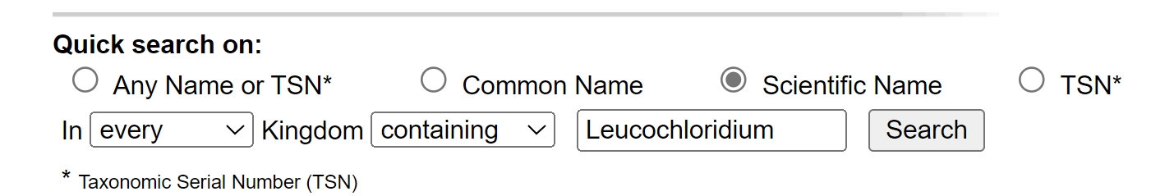

Question: The name next to the genus was the first person to describe the genus. In what year did this occur? 1835

- This genus was validated by a taxonomic expert, but their name does not appear on this page. The next database linked to ITIS will provide the name.
- Go back to the homepage Integrated Taxonomic Information System (itis.gov) and select The Catalogue of Life (CoL) link.
- In the CoL database, enter Leucochloridium in the Find Taxon box.
- Click on the Identifier Link (unique identifiers are assigned to all entries in a database).

Question: What is the name of the taxonomist in the box for taxonomic scrutiny (The name is shown as last name, first name)? Bray, Rod

Part 3 – What is the valid scientific name? The importance of validating that the correct taxonomist is listed in the data base.

Although the likelihood of a non-expert validating the name of a parasite is low (this is a niche field!), as a scientist it is very important to make sure the person listed matches their specialty. Google Scholar is a database that contains the works (books and peer-reviewed papers) of scientists.

- In google scholar, enter the name of the taxonomist from Part 2.G
- Next, find a reference listed in the search results. Choose one that shows the name of the researcher and the word trematode.
Question: Write the title of a book or paper about Trematodes written by the taxonomic scrutinizer. Keys to the Trematoda. Vol 3. Or other

Now, as an organismal biologist, you should feel confident that you did your due diligence in validation of a scientific name.

