Document 1: Zombie snail parasites. Taxonomy Overview

To begin, watch a video on the taxon of interest. Here, zombie snail parasites Zombie Snails | World's Deadliest - YouTube

Part I: Taxonomy- Linnaean Classifications

Define the following terms:

Taxon-
Taxonomy-
Nomenclature-
Epithet-

- OneZoom: In the search all life box: Enter “zombie snail parasites” (not zombie snail parasite without the plural ending as it yields a more specified search).

- Once the node (circle) on the tree appears, zoom in until you can see the image. Do not click on the image as it opens a new tab. Instead, at the bottom of the node is the scientific name of the family.

Question: What is the name of the family?

Question: What is the scientific epithet of the species that corresponds to the picture?

Question: Why is a family represented as a node and the species a leaf in the OneZoom tree of life?

- Now, zoom into the family and notice there are additional nodes that lead to the leaves. These nodes are at a finer scale hierarchical taxonomy, a genus. (*Note, when discussing more than one genus, the accepted term is genera NOT genuses).

Question: Write the names of the genera in this family?

- Wikipedia and associated links. Using the compass, return to the zombie snail parasites node. Click on the scientific name in the node and the corresponding Wikipedia page will open.

Question: In Wikipedia, refer to the scientific classification information found below the line drawings. How many genera are in this family?

Question: Refer to your answers in Part 1, C. How many genera are in this family according to OneZoom?

Question: What is a reason for the discrepancy between numbers of genera between OneZoom and Wikipedia?

- Higher levels of taxonomy.
Back to OneZoom– Click on the X in the upper right-hand corner of the screen to exit Wikipedia and return to OneZoom.
    - Select the compass icon in the toolbar on the lower left part of the screen. Select the term Flukes above Flatworms.
    - You will see the image below. Choose the larger node.

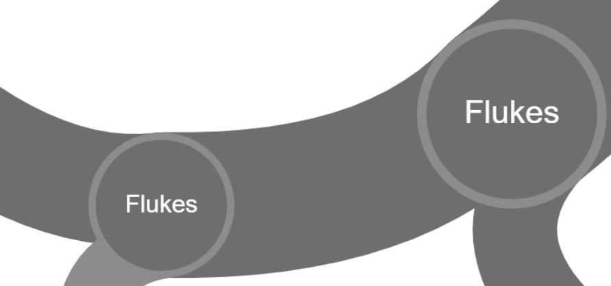

Question: What is the scientific name of this node and how many species are listed?

- Click on the scientific name in the node and the corresponding Wikipedia page will open. Under contents, select taxonomy to find the estimated numbers of species in this class.

Question: How many species (range) are found in this class?

Question: What is a reason for the discrepancy between numbers of species in this class between OneZoom and Wikipedia?

Part 2. Taxonomy: Nomenclature Problems with Common Names and the need for Taxonomy.

For this section, you will use an advanced search option known as the tracer tool to show the links between and among taxa in the form of a clade.

- To begin: in OneZoom, click on the green Y icon next to the search bar.
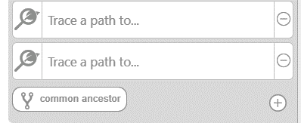

- The advanced tracer tool option is now active and the image to the right should be visible.

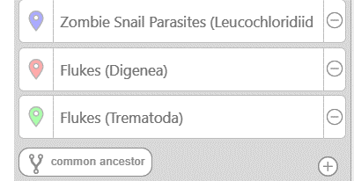
- Type zombie snail parasites in the first box and select the + in the lower right corner to add another box.
- Type Flukes (Digenea) in the second box and select the + in the lower right corner to add another box.
- Type Flukes Trematoda into the third box and select the + in the lower right corner to add another box.
- Type Flatworms in the fourth box.

INSERT A SCREENSHOT OF THE TREE BELOW.

The different colored lines correspond to each group, notice the hierarchical nature of taxonomy in the form of a cladogram with branching lineages.

Question: Based on this answer, what lineage is the largest?

Question: How many nodes occur between Flatworms and Flukes Digenea (do not include the lineages splitting from Digenea)?

Question: Why is the common name ‘Flukes’ problematic when discussing these flatworms?

