Faculty Data Analysis for Guided Approach

Yearly patterns in peak eagle numbers, December temperature, and salmon numbers.
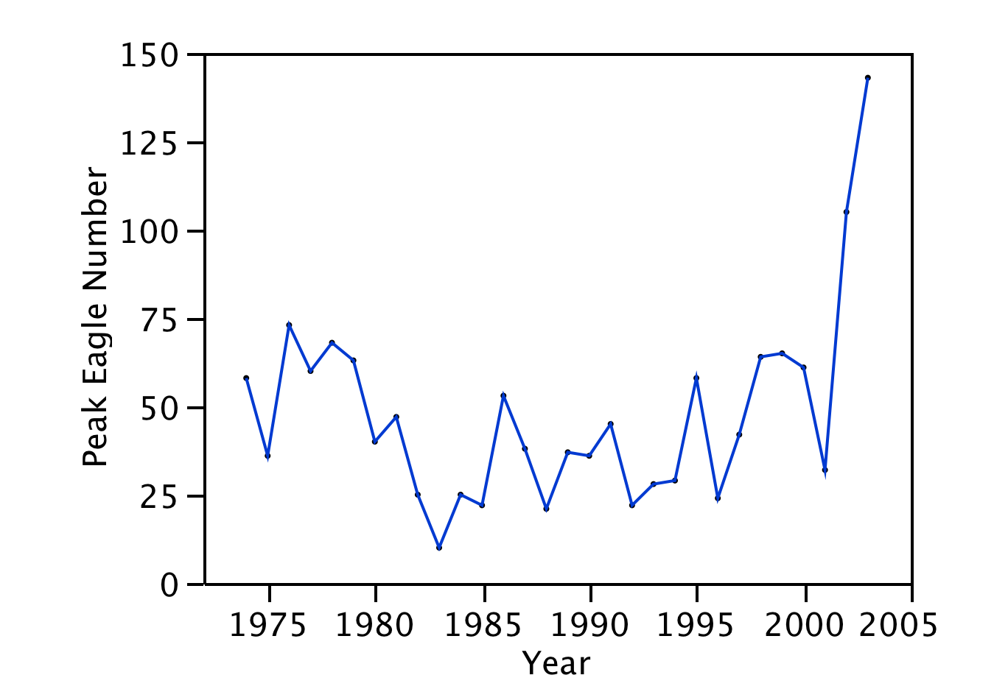

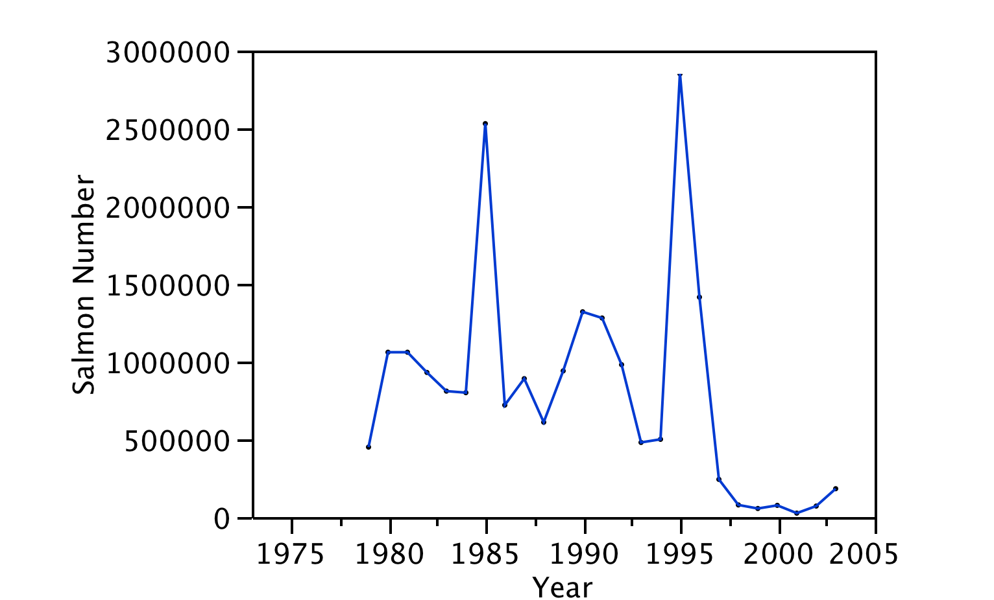
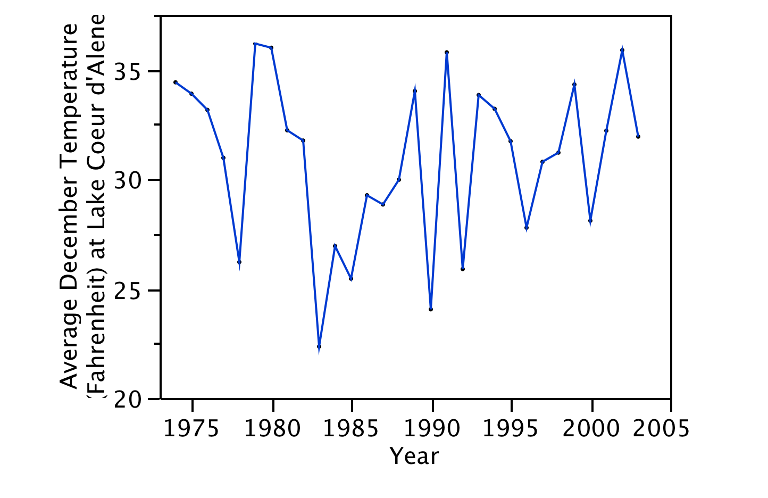
Outputs from regression analyses, including best-fit line for variables across time.

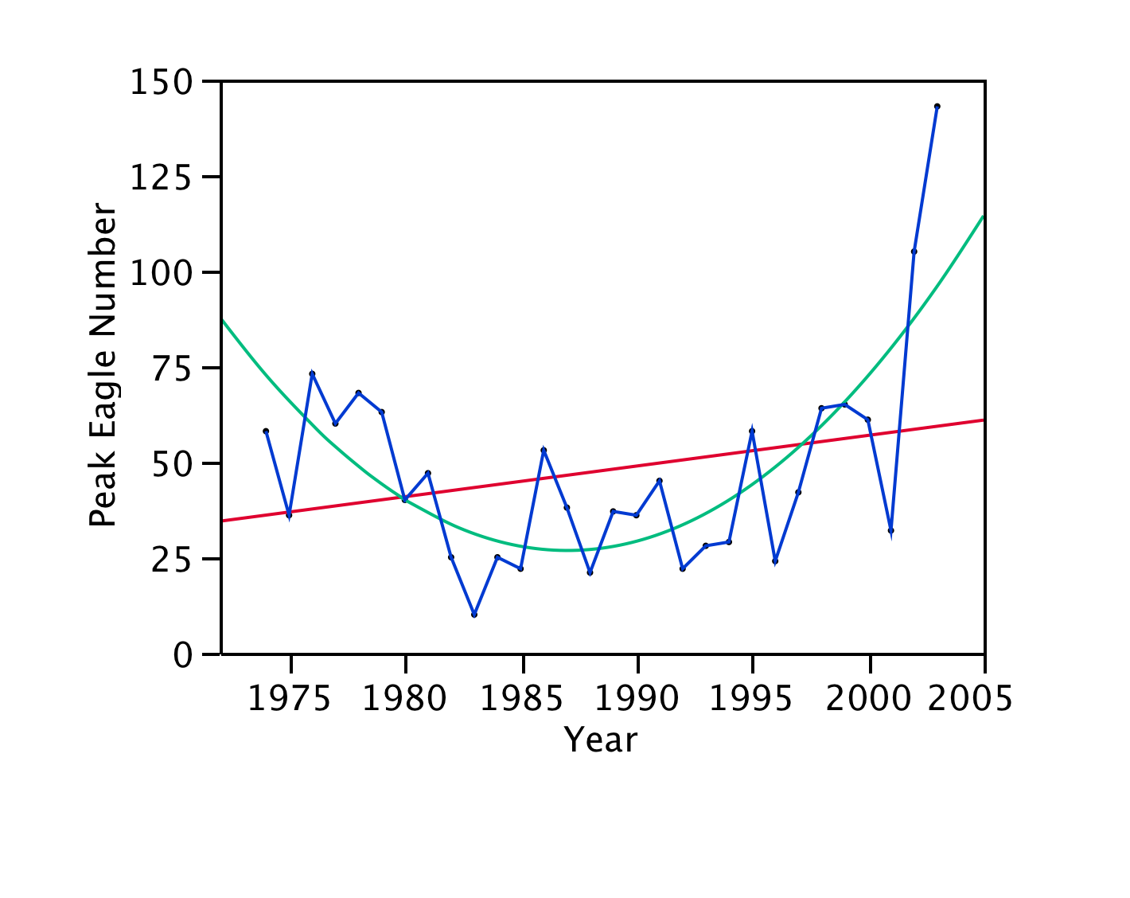
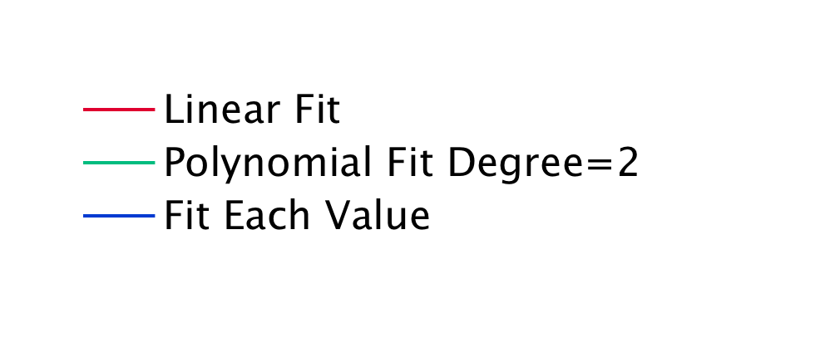
Polynomial regression outputs: r² = 0.53, n = 30, F = 15.10, P <0.0001.

Linear regression outputs: r² = 0.07, n = 30, F = 2.02, P = 0.16.

Pattern: Peak eagle number initially decreases over time then in the later decade the numbers increase over time.

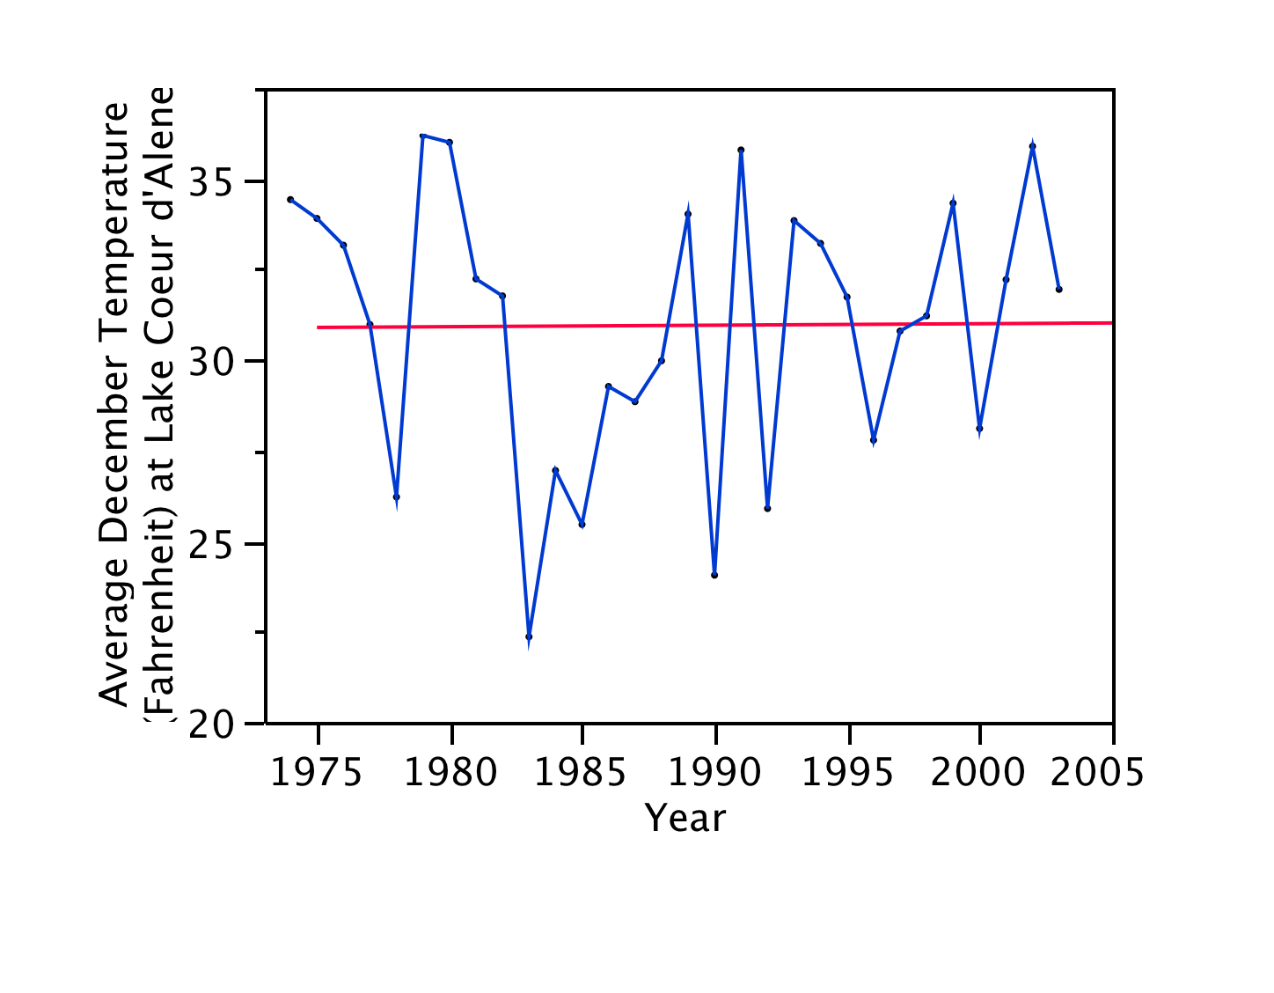
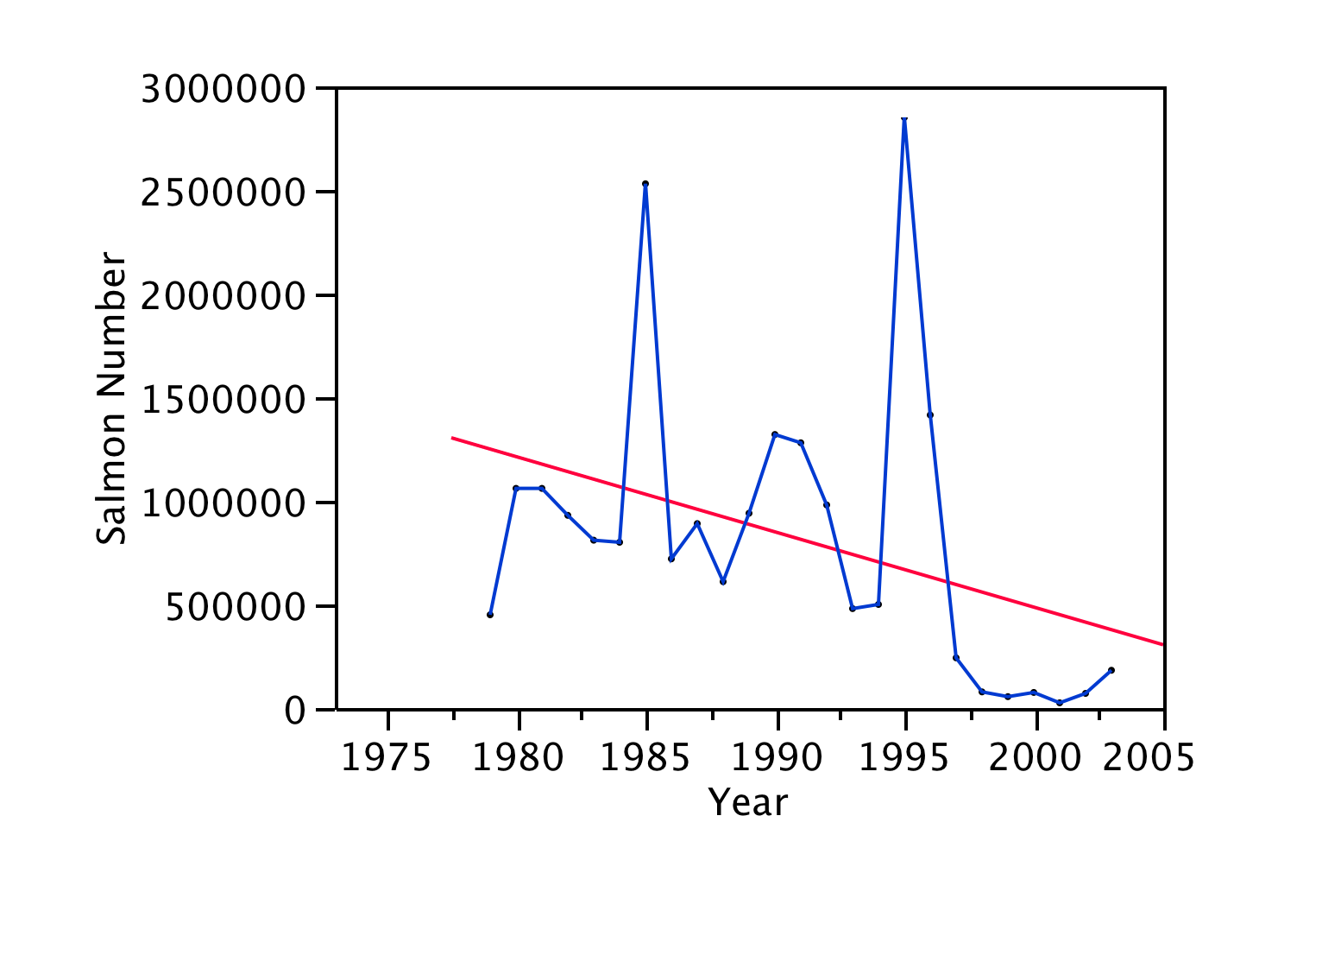
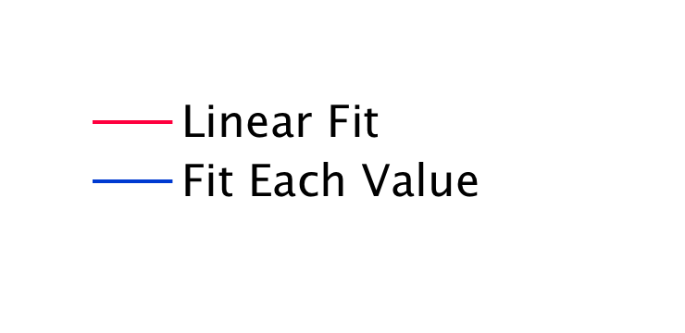
Linear regression outputs: r² = 0.0009, n = 30, F = 0.003, P = 0.96.

Pattern: Average December temperatures fluctuate from year to year but there is no general pattern over time.

Linear regression outputs: r² = 0.142, n = 25, F = 3.81, P = 0.06.

Pattern: Salmon numbers fluctuate widely from year to year and the data indicate a trend for decreasing salmon numbers across the decades.

Patterns in eagle numbers explained by temperature and salmon, including statistical outputs.
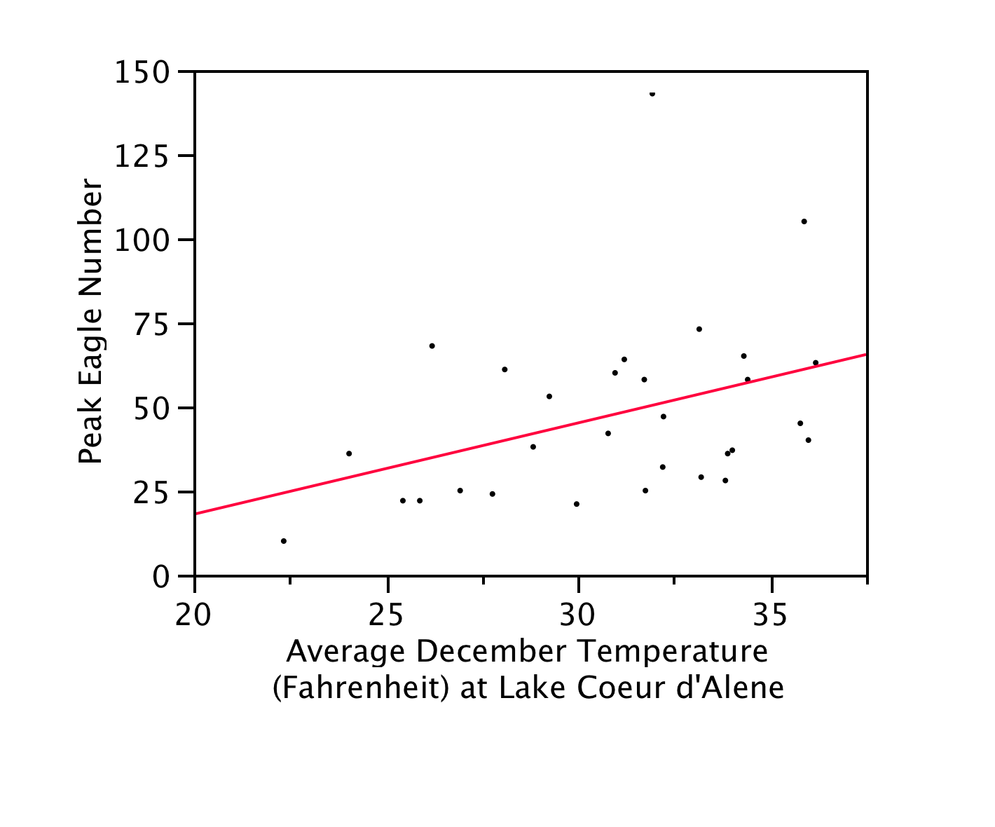
Regression outputs: r² = 0.141, n = 30, F = 4.59, P = 0.041.

Pattern: Peak eagle number increases with increasing average December temperature.

Why? If the temperature is too cold then the lake with freeze and the salmon will not be available to the eagles.

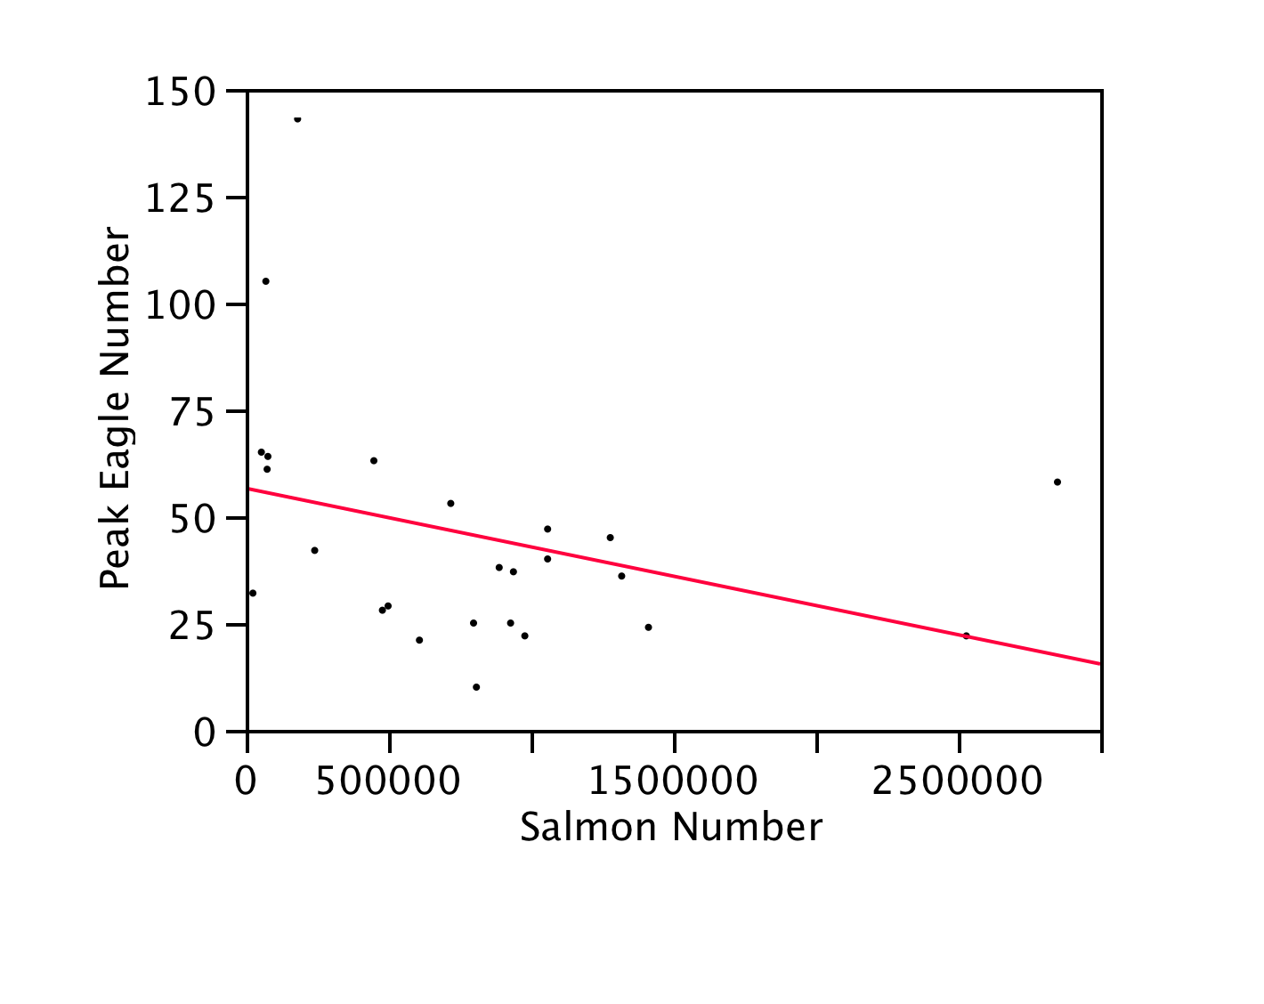
Regression outputs: r² = 0.114, n = 25, F = 2.97, P = 0.098.

Pattern: Peak eagle number decreases, although not significantly, with increasing salmon numbers.

Why? This relationship is counterintuitive. More salmon should attract more eagles. Possible explanations: eagles take so few salmon that there is no relationship or eagles are eating other food sources.

